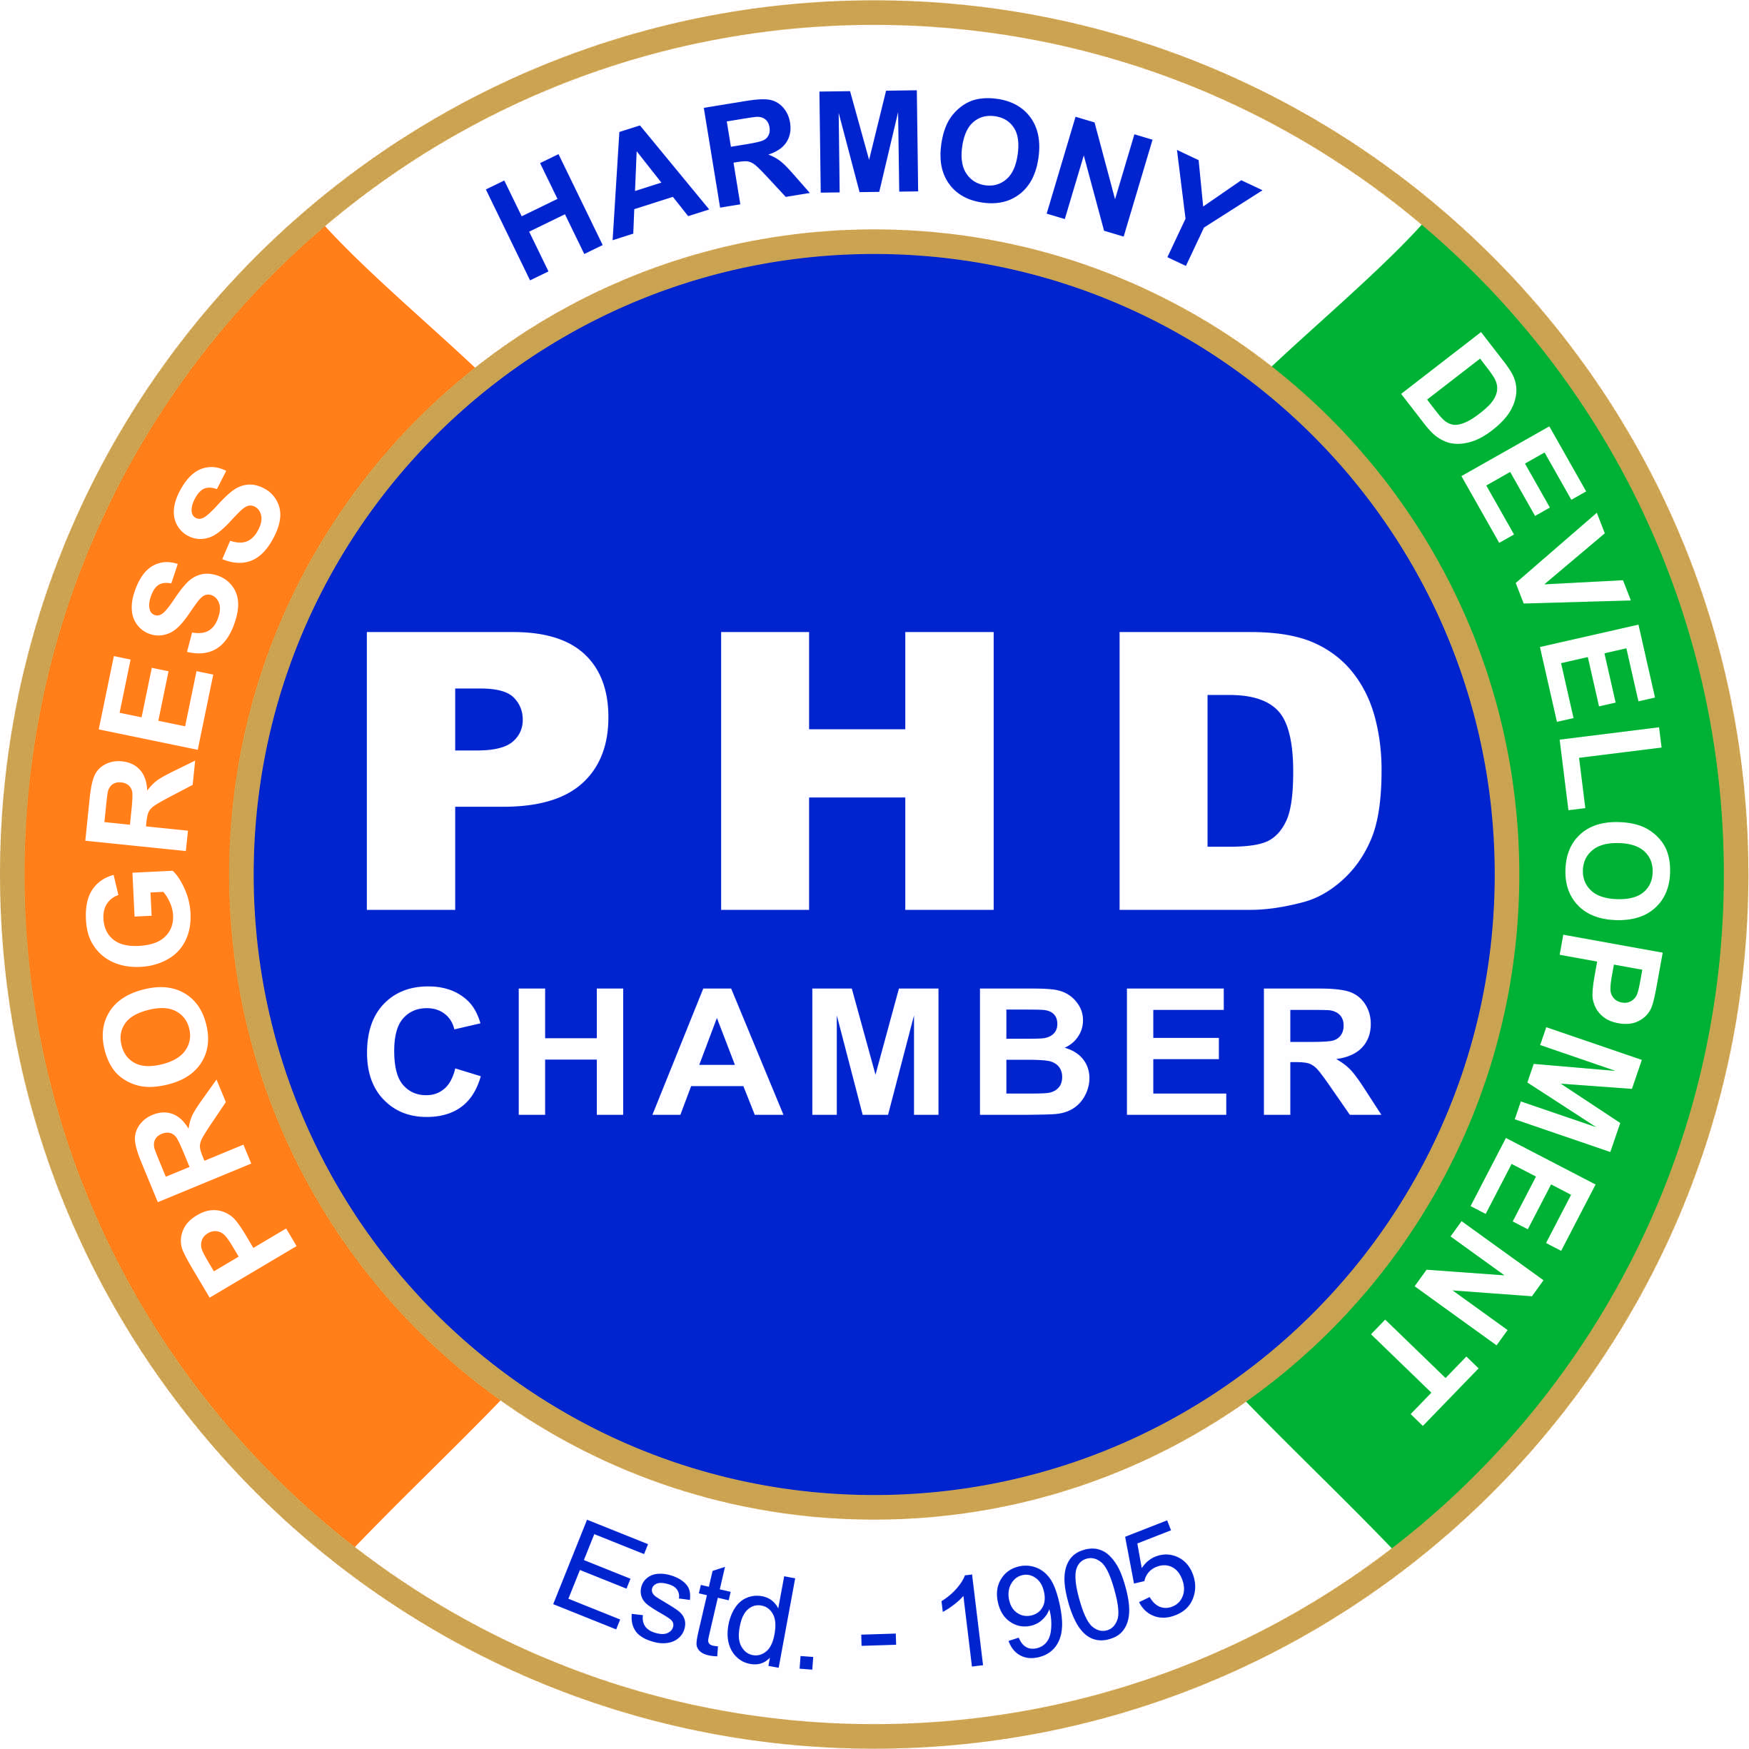
TIFS organized an Interactive Session on BREXIT
Beyond 2018: Remodelling UK’s Trade in Goods post BREXIT
Saturday, 17th February 2018 at PHD Chamber, New Delhi

An Interactive Session on BREXIT Beyond 2018: Remodelling UK’s Trade in Goods post BREXIT was organized by Trade and Investment Facilitation Services (TIFS) on Saturday, 17th February 2018 at 10:30 am at PHD Chamber, New Delhi. The session was addressed by Dr Sangeeta Khorana, Professor of Economics at Bournemouth University, United Kingdom. She shared insights about how trade profile of United Kingdom will alter after leaving European Union. Dr Sangeeta Khorana suggested for initiatives by PHD Chamber of Commerce and Industry for linkages with Chambers of Commerce in United Kingdom to strengthen bilateral trade and investment between both nations.

Interactive Session on BREXIT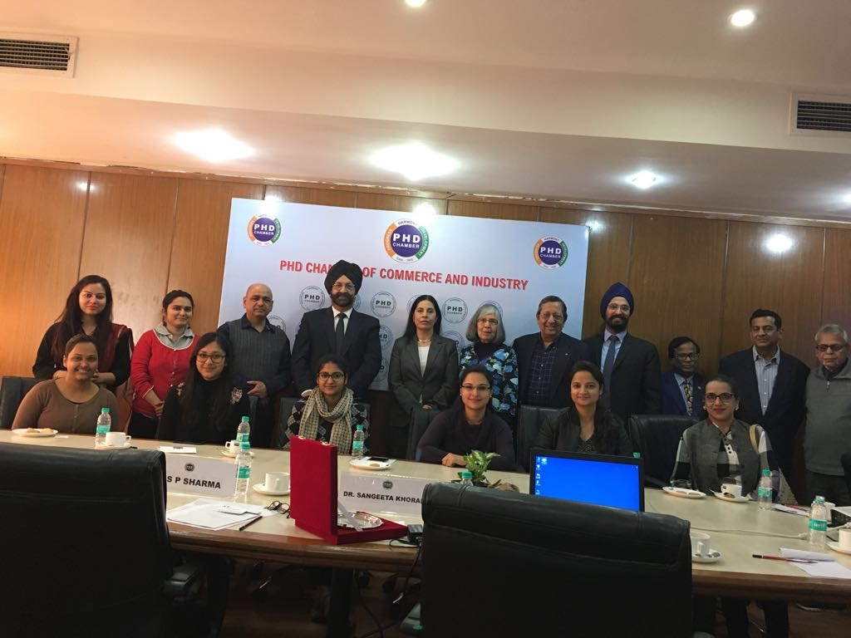
Participants at Interactive Session on BREXIT, 17th February 2018, PHD Chamber, New Delhi

