TIFS met with a delegation from Konrad Adenauer Stiftung (KAS)
7th March 2018 at PHD House, New Delhi
Trade and Investment Facilitation Services (TIFS) met with a delegation from Konrad Adenauer Stiftung (KAS), comprising of Prof. Dr. Heribert Dieter, Senior Associate, German Institute for International and Security Affairs; Mr. Peter Rimmele, Resident Representative India, Konrad Adenauer Stiftung (KAS); and Shri Pankaj Madan, Advisor/Team Leader Program Coordination, Konrad Adenauer Stiftung (KAS). The discussions were led by Shri Saurabh Sanyal, Secretary General, PHD Chamber; Shri CM Krishna, Honorary Advisor, PHD Chamber; Dr. S P Sharma, Chief Economist, PHD Chamber; Ms. Babeeta Sharma, Joint Secretary (Finance), PHD Chamber; Ms. Sunita Prajapati, Sr. Assistant Secretary, PHD Chamber; Ms. Surbhi Sharma, Sr. Research Officer; Shri Rohit Singh, Research Associate, PHD Chamber.

TIFS interaction with delegation from KAS
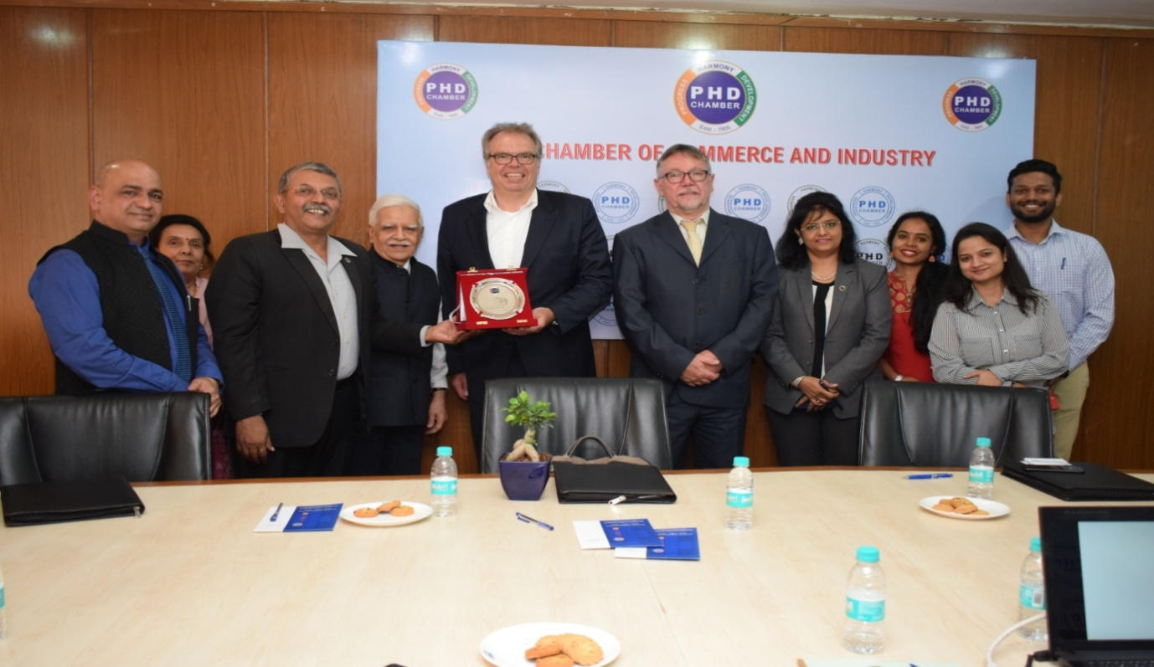
Left to right: Dr. S P Sharma, Chief Economist, PHD Chamber; Ms. Anju Bajaj, Proprietor, P‘n’A Industry; Shri Saurabh Sanyal, Secretary General, PHD Chamber; Shri CM Krishna, Honorary Advisor, PHD Chamber; Prof. Dr. Heribert Dieter, Senior Associate, German Institute for International and Security Affairs; Mr. Peter Rimmele, Resident Representative India, Konrad Adenauer Stiftung (KAS); Shri Pankaj Madan, Advisor/Team Leader Program Coordination, Konrad Adenauer Stiftung (KAS); Ms. Babeeta Sharma, Joint Secretary (Finance), PHD Chamber; Ms. Sunita Prajapati, Sr. Assistant Secretary, PHD Chamber; Ms. Surbhi Sharma, Sr. Research Officer; Shri Rohit Singh, Research Associate, PHD Chamber.
The discussions focused on strengthening the business and investment relations between India and Germany. TIFS also discussed about the growing trade relations between India and Germany. Further, prospects of a potential Free Trade Agreement (FTA) and issues thereof, outward and inward investments were deliberated during the discussions.

