TIFS interaction with the Chinese Delegation
TIFS interacted with the delegates at the Seminar on Indian Infrastructure and Real Estate Scenario held on 4th October 2017 at PHD House, New Delhi. The deliberations focused on enhancing business and entrepreneurial engagement between Indian and Chinese business community. TIFS team including Dr. SP Sharma, Chief Economist; Ms. Megha Kaul, Associate Economist; Mr. Rohit Singh, Research Associate; and Ms. Areesha Fatma, Research Associate, PHD Chamber interacted with the members of Chinese delegation at PHD House.
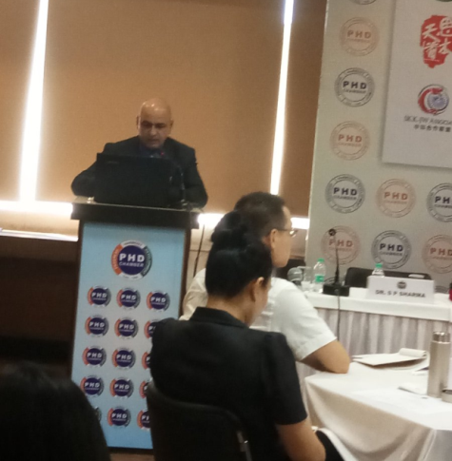
Dr. SP Sharma, Chief Economist, PHD Chamber

