PHD Chamber launched Trade and Investment Facilitation Services (TIFS)

PHD Chamber of Commerce and Industry has launched a specialized desk on “Trade and Investment Facilitation Services (TIFS)” on Friday, 31st March, 2017 at PHD Chamber House, New Delhi. The portal was launched by the Chief Guest of the event Hon’ble Mr. Amitabh Kant, CEO, NITI Aayog.
Trade and Investment Facilitation Services (TIFS) is a vital component for international trade and investment community. It is envisioned to facilitate firms across the globe for trade and investments in India while simultaneously meeting India's rapidly growing appetite for new markets to enhance trade and investments. TIFS aims to make India a US$ 100 billion (per annum) investment destination in the next five years and to enhance India's trade trajectory to the higher level. It envisages US$ 1000 billion merchandize trade (exports and imports) and US$ 500 billion services trade (exports and imports) per annum in the next five years.
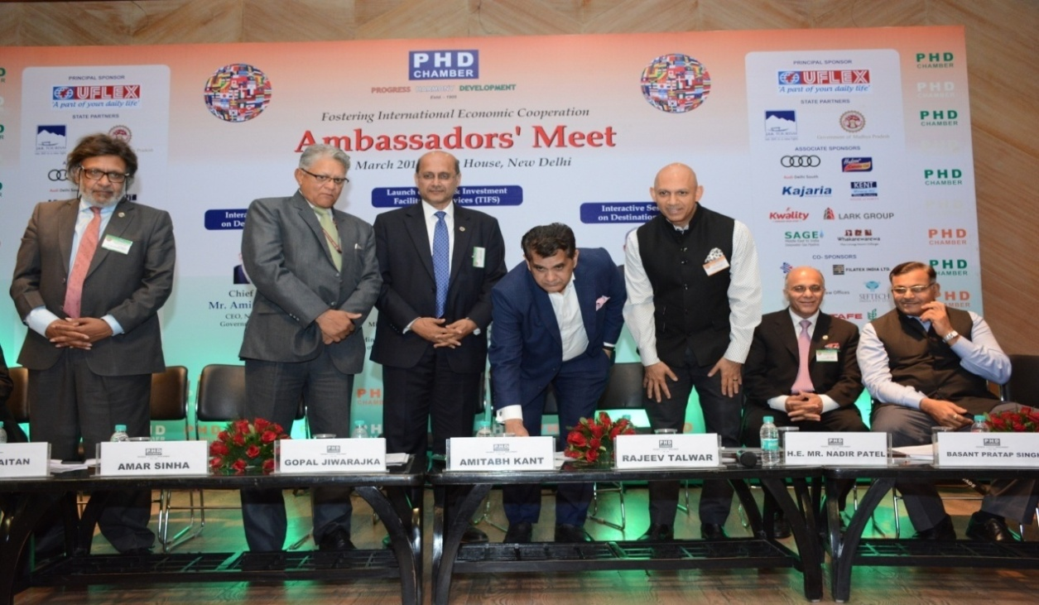
From left to right: Shri Anil Khaitan, Sr. Vice President, PHD Chamber, Mr. Amar Sinha, Secretary (ER), Ministry of External Affairs, Government of India, Mr. Gopal Jiwarajka, President, PHD Chamber, Mr. Amitabh Kant, CEO, NITI Aayog, Government of India, H.E. Mr. Nadir Patel, High Commissioner, High Commission of Canada, Mr. Rajeev Talwar, Vice President, PHD Chamber and Shri Basant Pratap Singh, Chief Secretary, Government of Madhya Pradesh

