## PHD Chamber Business Delegation to Germany and Hungary

PHD Chamber mounted a business delegation to Germany and Hungary, exhibiting at the India Pavilion at Interpack 2017, Dusseldorf. Over the course of the visit, various notable meetings were conducted with eminent organizations, helping to strengthen economic and trade ties between the nations. Business Delegation to Germany from 3rd – 9th May 2017 leaded by Mr. Gopal Jiwarajka, President, PHD Chamber to promote India's exports on a sustained basis through accessing new markets and increasing the share in the existing markets by inaugurating the INDIA PAVILION with about 50 exhibitors during the Interpack 2017 at Dusseldorf, Germany.

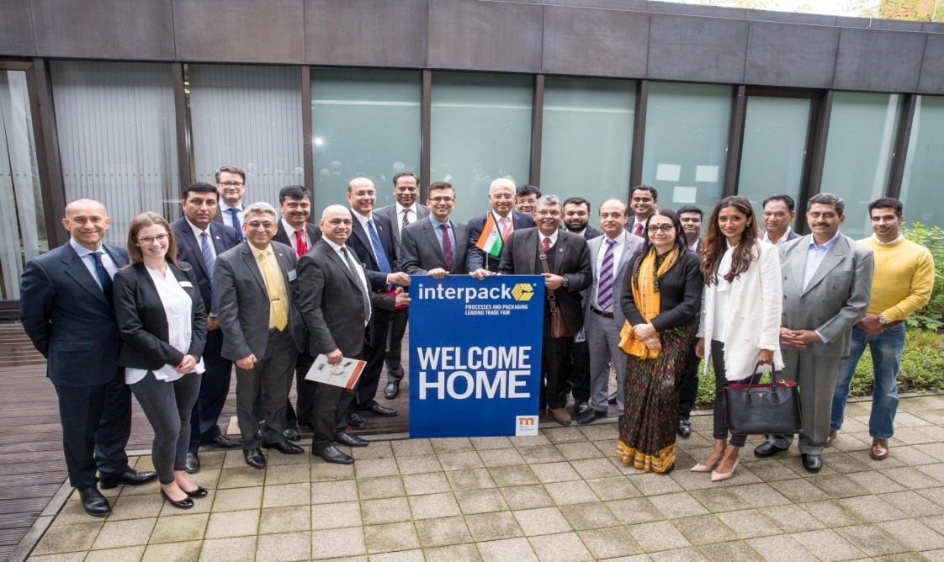

PHD Chamber Delegation to Germany and Hungary, exhibiting at the India Pavilion at Interpack 2017, Dusseldorf met Mr. Raveesh Kumar, Consulate General of India, High Commission of India in Frankfurt; Ms. Katharina von Maltzan, IHK Frankfurt am Maim; Mr. Oliver Wack, Area Manager, VDMA Association; Mr. Dirk Matter, Director, Indo-German Chamber of Commerce and Industry; Mr. Rajesh Nath, Managing Director, VDMA; Mr. Vikram Vardhan, Second Secretary (Eco & Com), High Commission of India to Germany; Mr. Vijay Khanduja, Counsellor (POL/COM), High Commission of India in Budapest; Ms. Ilona Leimeter, Area Manager, Department of International Affairs, Hungarian Chamber of Commerce and Industry; Mr. Istvan Grafjodi, Vice President, Division for Development of Relations with India, Budapest Chamber of Commerce and Industry.

|  |  |
| --- | --- |
| IMG_1206.JPG | **Location:** Frankfurt, Germany  **Description:** The Business Delegation from PHD Chamber met **with H.E. Mr. Raveesh Kumar, Consulate General of India, High Commission of India in Frankfurt**. The discussions were highly business oriented and focused on enhancing the trade ties between India and Germany. |
| **Location:** Frankfurt, Germany  **Description:** The Business Delegation from PHD Chamber met with **VDMA (Verband Deutscher Maschinen- und Anlagenbau**, Mechanical Engineering Industry Association). It represents more than 3,200 mostly medium-sized companies in the capital goods industry, making it the largest industry association in Europe. | IMG_1203.JPG |
| IMG_1204.JPG | **Location:** Dusseldorf, Germany  **Description:** The Business Delegation from PHD Chamber met with **Mr. Dirk Matter, Director, Indo-German Chamber of Commerce and Industry.** The discussions were focused on expanding relations and engaging in collaborative work. |
| **Location:** Frankfurt, Germany  **Description:** The Business Delegation from PHD Chamber met with **Ms. Katharina von Maltzan, Director International Business India and Asia Pacific, IHK Frankfurt am Maim.** The meeting with Ms. Katharina went highly constructive and fruitful. The discussions involved enhancing business, trade and investment ties between two nations. | IMG_1205.JPG |
| IMG_1207.JPG | **Location:** Berlin, Germany  **Description:** The Business Delegation from PHD Chamber met with **Mr. Vikram Vardhan, Second Secretary (Eco & Com), High Commission of India to Germany.** The discussions were focused on enhancing trade and business ties between Indian and German business community. |
| **Location:** Budapest, Hungary  **Description:** The Business Delegation from PHD Chamber met with **Ms. Ilona Leimeter, Area Manager, Department of International Affairs, Hungarian Chamber of Commerce and Industry.** The business deliberations focused on enhancing business and entrepreneurial engagement between Indian and Hungarian business community. | IMG_1199.JPG |
| IMG_1200.JPG | **Location:** Budapest, Hungary  **Description:** The Business Delegation from PHD Chamber met with **Mr. Istvan Grafjodi, Vice President, Division for Development of Relations with India, Budapest Chamber of Commerce and Industry.** The deliberations were focused on enhancing collaborative engagements between PHD Chamber of Commerce and Industry and Budapest Chamber of Commerce and Industry. |
| **Location:** Budapest, Hungary  **Description:** The Business Delegation from PHD Chamber met with **Mr. Vijay Khanduja, Counselor (POL/COM), High Commission of India in Budapest.**  Mr. Gopal Jiwarajka, President, PHD Chamber presented the auspicious memento to the Counselor. | IMG_1201.JPG |