Trade and Investment Facilitation Services (TIFS) met with Mr. Gitesh Agarwal, Queensland Trade and Investment Commissioner – India, Trade and Investment Queensland
11.00 am, Thursday, 25th January 2018, PHD Chamber
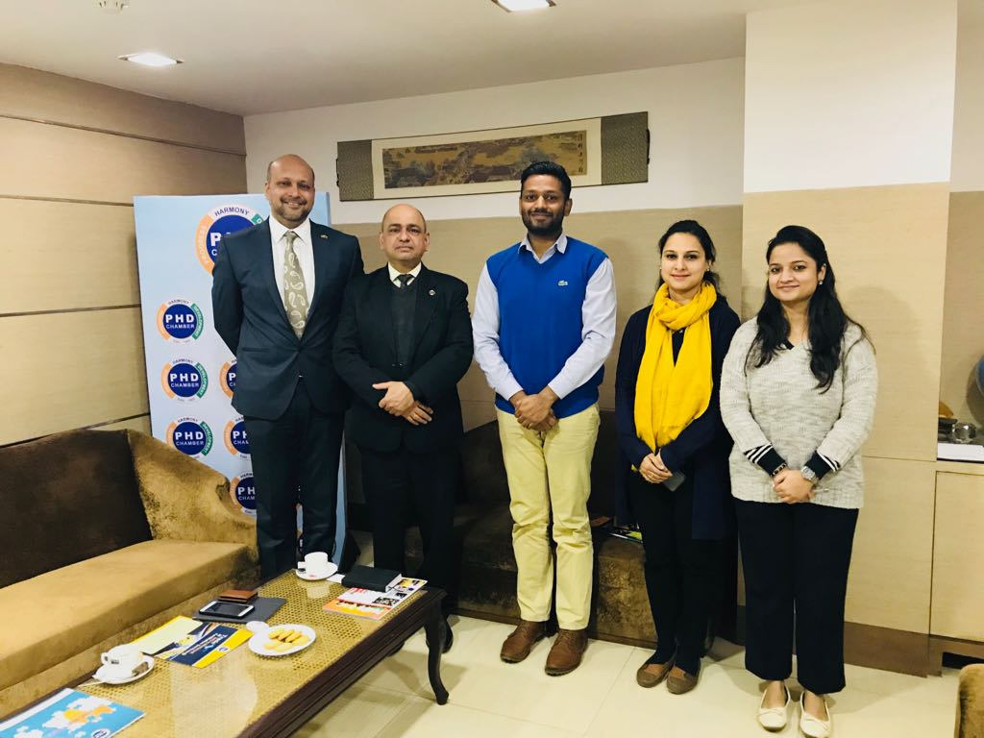
From left to right: Mr. Gitesh Agarwal, Queensland Trade and Investment Commissioner – India, Trade & Investment Queensland; Dr. SP Sharma, Chief Economist, PHD Chamber; Mr. Rohit Singh, Research Associate, PHD Chamber; Ms. Megha Kaul, Associate Economist, PHD Chamber; Ms. Surbhi Sharma, Senior Economic Officer, PHD Chamber.

Trade and Investment Facilitation Services (TIFS) met with Mr. Gitesh Agarwal, Queensland Trade and Investment Commissioner – India, Trade & Investment Queensland to explore about various business and investment opportunities in the North Eastern State of Australia, Queensland. The vital areas highlighted by Mr. Agarwal were biotechnology, sustainable mining, pharmaceutical, smart infrastructure, advanced manufacturing, drone technology, tourism among others.
Mr. Agarwal also focused on deliberating on areas like technology transfer for manufacturing and food processing segment, business skill migration, promotion of startups through their dedicated desk called HOTDESQ among others. He suggested that TIFS should mount a business delegation to Queensland in the coming months, wherein the Trade and Investment Queensland, Australia will ensure that the visit would be a proper mix of deliberating on fruitful trade and investment opportunities and leisure. In addition, he suggested that TIFS should organize a seminar for the members of the PHD Chamber on Endless Opportunities in Queensland and the commissioner suggested that he, along with the some senior dignitaries from the Australian High Commission could address the gathering.

