## B2B Meetings with Business Delegation from Romania: Strengthening India- Romania Business Relations

## PHD Chamber of Commerce and Industry in collaboration with Romania-India Chamber of Commerce and Industry (RICCI) have organized an interactive session with a high-powered Romanian delegation on 11th April, 2017 at PHD House, New Delhi. The delegation was leaded by H.E. Mr. Cristian DIMA, Secretary of State, Ministry for Business Environment, Commerce and Entrepreneurship, Chairman of the Romanian side. The other delegates were H.E. Mr Radu Dobre, the Ambassador of Romania, Mr. Valentin BREBENEL, Director, Strategy and External Relations Directorate Asia, America, Africa and Middle East, Department of Foreign Trade, Ministry for Business Environment, Commerce and Entrepreneurship, Mr. Emil Octavian IONESCU, Director, Business Directorate, Ministry for Business Environment, Commerce and Entrepreneurship, Mr. Marian POSTELNICU, Counsellor, Strategy and External Relations Directorate Asia, America, Africa and Middle East, Department of Foreign Trade, Ministry for Business Environment, Commerce and Entrepreneurship and Mr. Ionut Mircea VIZIRU, Economic Counselor, Head of Economic and Trade Promotion Office, Embassy of Romania  in India.

## The participants from PHD Chamber in the interactive session were Shri Anil Khaitan, Senior Vice President, PHD Chamber, Shri Vijay Mehta, Chairman, Economic Affairs Committee, PHD Chamber and President, Romania-India Chamber of Commerce and Industry (RICCI), Dr. SP Sharma, Chief Economist, PHD Chamber and Shri Yogesh Shrivastav, Director, PHD Chamber along with the stakeholders of various sectors of the economy.

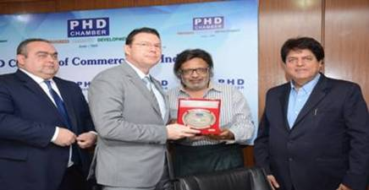

H.E. Mr Radu Dobre, Ambassador of Romania, H.E. Mr. Cristian DIMA, Secretary of State, Ministry for Business Environment, Commerce and Entrepreneurship, Chairman of the Romanian side, Shri Anil Khaitan, Senior Vice President, PHD Chamber and Shri Vijay Mehta, Chairman, Economic Affairs Committee, PHD Chamber and President, Romania-India Chamber of Commerce and Industry.